**Project Design Phase-II**

**Technology Stack (Architecture & Stack)**

|  |  |
| --- | --- |
| Date | 15 October 2022 |
| Team ID | PNT2022TMID28212 |
| Project Name | Early Detection of Chronic Kidney Disease using Machine Learning |
| Maximum Marks | 4 Marks |

**Technical Architecture:**

The Deliverable shall include the architectural diagram as below and the information as per the table1 & table 2

|  |  |  |  |
| --- | --- | --- | --- |
| **S.No** | **Component** | **Description** | **Technology** |
| 1. | User Interface | An Interface for the user to interact with the prediction model. | HTML, CSS, JavaScript |
| 2. | User Registration | User can register in the web application | HTML forms |

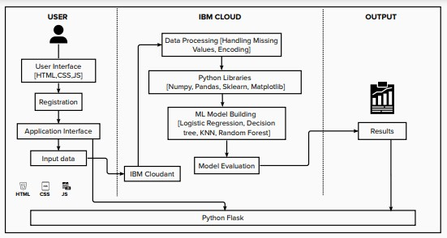

**Table-1 : Components & Technologies:**

|  |  |  |  |
| --- | --- | --- | --- |
| 3. | Disease Prediction | The user enters the data which is given as input to model to predict the disease. | Machine Learning with Python. |
| 4. | Update Prediction result | The result of disease prediction is updated in the Web UI for the user to know the output. | Python. |
| 5. | Database | Relational database structure to store the user data | MYSQL. |
| 6. | Cloud Database | Database services on IBM cloud. | IBM Cloudant. |
| 7. | Machine Learning Model | To predict he chronic kidney disease (CKD) with various input parameters. | Random Forest, KNN, Decision tree, Logistic Registration. |
| 8. | Infrastructure (Server / Cloud) | Application Deployment on  Cloud | IBM Cloud. |

**Table-2: Application Characteristics:**

|  |  |  |  |
| --- | --- | --- | --- |
| **S.No** | **Characteristics** | **Description** | **Technology** |
| 1. | Open-Source Frameworks | The python open-source frameworks are used to build the web application as well as to build Machine Learning model. | Python Flask, Numpy, Scikit-Learn etc. |
| 2. | Scalable Architecture | The 3-tier architecture used with a separate user interface, application tier and data tier make it easily scalable. | IBM Watson Studio. |
| 3. | Availability | The web application is highly available as it is deployed in cloud. | IBM Cloud. |
| 4. | Performance | The performance of the website is improved with caching and security. | IBM Cloud Internet Services. |